Part Three: “crossover connection”

BONUS POINTS

It should be possible to establish a direct connection from your Linux host machine to your Beaglebone using an ethernet patch cable; in older systems, the ethernet cable had to be a “crossover” type to allow a direct link, however, modern systems can work with a conventional patch cable. Investigate this type of connection, and see if you are able to do it! Name your sources in your discussion. This part is strictly for bonus points.

STEP-1:
Here, the settings for a Linux desktop to enable network are below:
- Along with internet-over-USB device attached, just type ifconfig in terminal, then we will get the display of attached network interfaces.
- The next step is to find the main adapter (eg.,eth0) and internet-over-USB adapter(e.g.,eth1).

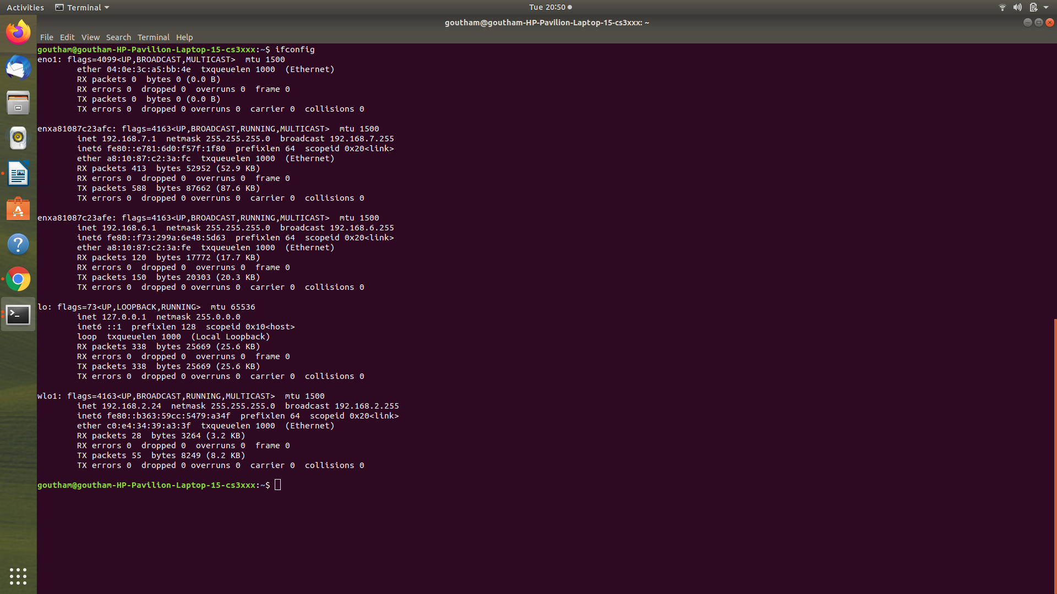
Here, the eth0 is “wlo1” and eth1 is “enxa81087c23afe” from the above screenshot.

STEP-2:
Login in to your beaglebone by typing ssh debian@192.168.7.2
Here we have to use the iptables program for configuring the Linux kernel firewall rules.

debian@beaglebone:~$ sudo iptables --table nat --append POSTROUTING --out-interface eth0 -j MASQUERADE

In place of eth0, type wl01 and the command changes as below.
Run it on your beaglebone machine, and give the password as temppwd.

debian@beaglebone:~$ sudo iptables --table nat --append POSTROUTING --out-interface wl01 -j MASQUERADE

STEP-3:

Similarly, in the following command
debian@beaglebone:~$ sudo iptables --append FORWARD --in-interface eth1 -j ACCEPT

Replace eth1 with enxa81087c23afe.Run the below command on your beaglebone.

debian@beaglebone:~$ sudo iptables --append FORWARD --in-interface enxa81087c23afe -j ACCEPT

Followed by below command,
debian@beaglebone:~$ sudo sh -c "echo 1 > /proc/sys/net/ipv4/ip_forward"

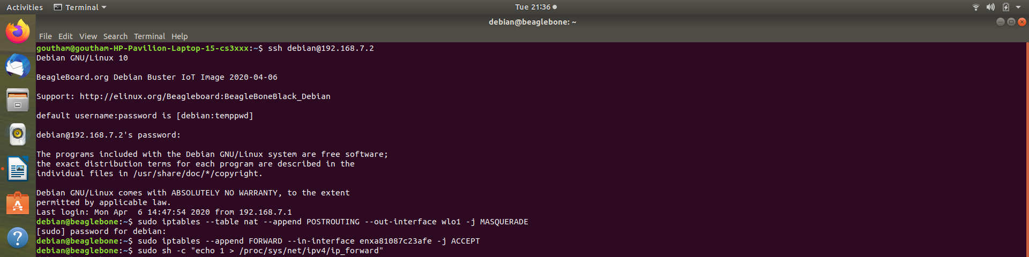

INTERNET-OVER-USB NETWORK SETTINGS

Now type the command debian@beaglebone:~$ ping 8.8.8.8
If the process gets started it will be fine otherwise we need to type the following command before we proceed to root.
root@beaglebone:~# route add default gw 192.168.7.2
After this change it to root user by entering the following command.
debian@beaglebone:~$ sudo -i
The user changes to root@beaglebone

Then type ping www.google.com to ping the website and the process begins as follows.

